**SIT 100 GROUP 2 ASSIGNMENT**

1. Joy Muthoni Mwangi- SC232/1242/2021
2. Francis Kabu Gitau-SC232/1288/2021
3. Edwin Kimani Kang’ethe-SC232/1256/2021
4. Moses Kiruthu Maru-SC232/1244/2021
5. Njeru Violet Kagwiria-SC232/1986/2021
6. Daisy Omuya-SC232/1282/2021
7. Newton Gitonga-SC232/1274/2021
8. Anthony Ngunjiri-SC232/0260/2021
9. **What is mail merging? And what is the procedure for carrying out mail merging in a word processing document?**

Mail merging is the process of combining a list of data with template.

**Procedure**:

* In a blank Microsoft word document, click on the mailing tab, in the start mail merge group, click start mail merge.
* Click step by step mail merge wizard.
* Select your document type, **CLICK NEXT, STARTING DOCUMENT**
* Select the starting document **USE THE CURRENT (BLANK) DOCUMENT.** Click next : **SELECT RECIPIENTS.**
* In the select recipients, type a new list and then click create.
* Write the letter and add custom filled:
  + Click address block to add recipient addresses at the top of the document
  + In the insert address block dialogue box, check or uncheck boxes and select options on the left until the address appears the way you want it to.

* Press enter on your keyboard and click on the greeting line, then click next after you have finished writing a letter.
* In the insert greetings line dialogue box, choose the greeting line format by creating the dropdown arrows and selecting the options of your choice then click ok.
* Note the address block and greeting line are surrounded by chevrons(<< >>).write a short letter and click next: preview your letter

**Completing the merge**

* click **print** to print your letter or edit individual letters to further personalize some or all of the letter.

1. **Using examples in each case, differentiate between sorting and filtering as used in spreadsheet applications?**

Sorting is putting data in order while filtering data lets you hide an important data and focus only on the data you are interested. Example of sorting is putting students name in alphabetic order while that of filtering is where in a class of students who have done an exam, the students’ marks below a certain mark are removed from the list.

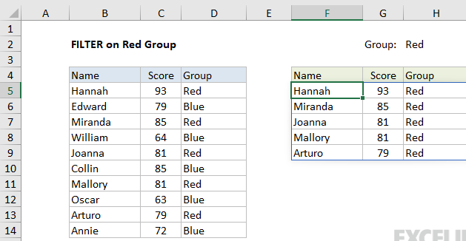

1. **What is Automatic Table of Content (TOC)? What is the procedure of inserting an automated TOC in a word processing document?**

It is a function that can automatically generate a table of contents for your documents, provided you correctly tag the chapter headers and sub-headers that you wish to show in your table of content.

**Procedure:**

1. Place your cursor where you want your table of contents to be.
2. On the References Ribbon, in the **Table of Contents Group**, click on the arrow next to the Table of Contents icon, and select Custom Table of Contents.
3. If you want to change the style of your table of contents (e.g. you want more space between the items on level 1 and level 2 of your table of contents, or you want all your level 1 items to be bold), click on the Modify button, select the TOC level you want to change, then click the Modifybutton to do so.
4. If you want to change which headings appear in your table of contents, you can do so by changing the number in the Show levels: pulldown.
5. Click OK to insert your table of contents.
6. **You are the ICT officer in MUT, you have been asked by the University Management to prepare a customized template for MUT to be used by all the respective schools and departments during the conference. Define what a master slide is and explain the process of creating a master slide with MUT logo and color.**

A master slide is the main slide that defines and sets the layout, color, fonts, background, effects and most of everything else for the slides that follow it. Any changes you do to a font or upload a logo in the master slide they will be applied to all slides below automatically.

**Procedure:**

* To add a MUT logo to all slides, select **view** then **slide master.** Scroll to the top of the thumbnail pane on the left and then insert the first items, the slide master.
* Select **insert** then **shapes,** pick a shape and then click and drag to draw the text book on the slider master. It should be about the same sizes as your logo. Since MUT logo is circular, then the logo should use a circle.
* Right click on the **format shape** to open the menu.
* Under the bucket icon, select  **fill**  then **picture fill** and then insert your logo image. To adjust the brightness of the logo use the transparency slide.
* To add the colors present in the MUT logo such as green, black, red and white, click on the design tab and select the colors.
* To remove the board around the image, select the logo and then right click **outline** then select **no outline.**